Python-Functions What does the len() function do in Python?
The len() function in Python returns the number of items in an object. It can be used with various data types such as strings, lists, tuples, dictionaries, and sets.
Write a code example using len() to find the length of a list.
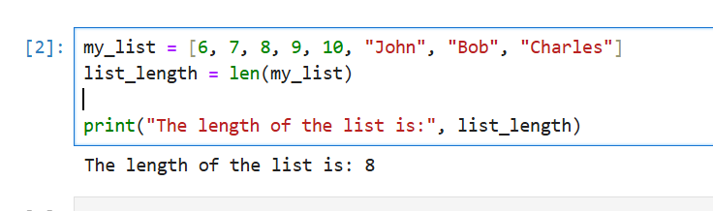
Write a Python function greet(name) that takes a person's name as input and prints "Hello, [name]!".
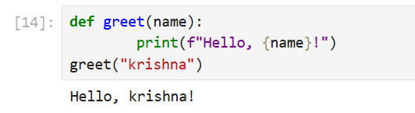
Write a Python function find_maximum(numbers) that takes a list of integers and returns the maximum value without using the built-in max() function. Use a loop to iterate through the list and compare values.
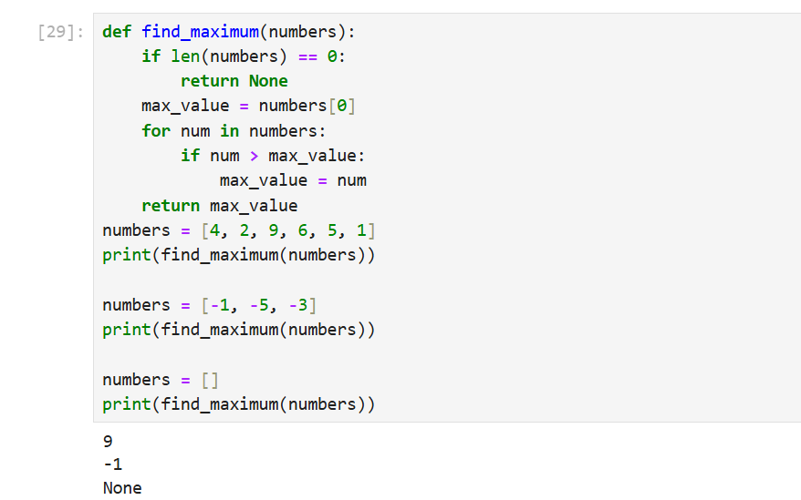
Explain the difference between local and global variables in a Python function.
Local vs Global Variables in Python
In Python, variables can be either local or global. The main difference between the two is their scope and accessibility.
Local Variables
- Defined within a function or a block of code.
- Only accessible within that function or block.
- Created when the function is called and destroyed when the function returns.
- Must be assigned a value before use.
Global Variables
- Defined outside of any function or block.
- Accessible from anywhere in the program.
- Retain their value between function calls.
- Can be accessed and modified within functions

Write a program where a global variable and a local variable have the same name and show how Python differentiates between them.
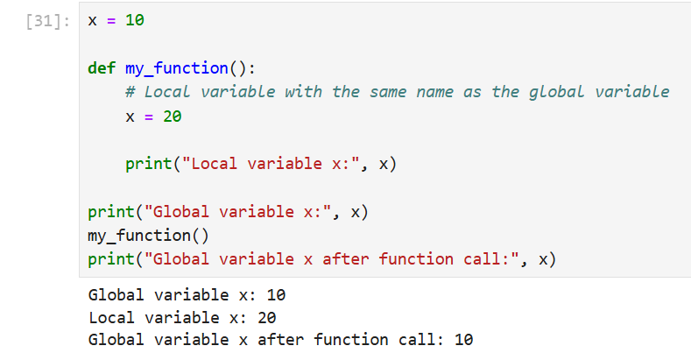
Create a function calculate_area(length, width=5) that calculates the area of a rectangle.
If only the length is provided, the function should assume the width is 5.
Show how the function behaves when called with and without the width argument.
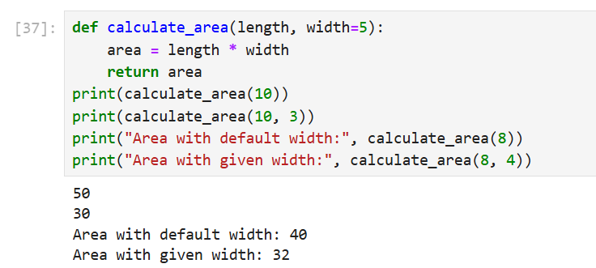
Note: For the theory or explanatory parts of the questions, you may include your explanations as comments within the Python file itself. Alternatively, you can provide detailed explanations in a separate Word/PDF document and upload it along with your assignment.

